User Manual

# Introduction

This document describes how to use each component of the framework. Before you start reading this you should preferably have read the conceptual introduction of the framework. You should also have read the user quickstart if you are not familiar with the framework. It describes how to set up and launch every component of the framework.

For an explanation of the code or the software in general, head over to the code documentation or the developer quick start respectively.

Contents

Introduction 1

# TElosB XML Parser

The WSN parser exists out of one window:

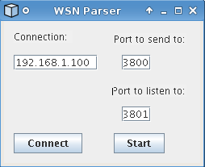

Under the textbox “Connection” you enter the IP of the controller.

Under the textbox “Port to send to:” you enter the port you must transmit your data to.

Under the textbox “Port to listen to:” you enter the port you want to listen on for requests transmitted by the controller

The button “Connect” is used to set up the connection, so the socket are created.

The button “Start” is used to start listening and sending packets.

# Controller

The controller consists out of a single form and a console window. On this form the user can select a localization algorithm, RSS filter and method of calibration. Below is a screenshot of the form.

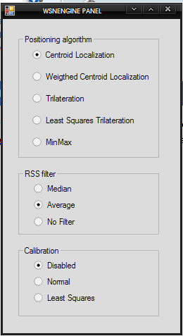

In the upper groupbox you can select the localization algorithm. The user can choose from:

* Centroid Localization
* Weighted Centroid Localization
* Trilateration
* Least Squares Trilateration
* MinMax

In the middle groupbox you can select the RSS filter. The user can choose from:

* Averaging filter
* Median filter
* False filter (The data will not be filtered)

In the lower groupbox you can select the calibration method. The user can choose from:

* Disabled
* Normal (Our own implementation of calibration)
* Least Squares Calibration

By choosing the parameters the user will affect the localization performance and behavior

The controller also provides a console window on which important information is printed out.

# GUI